FIELD PROJECT

A Study on Consumer Preference for Digital Payment Methods and Applications

  - A Project submitted to

BHAVANS COLLEGE
DEPARTMENT OF STATISTICS
An Academic project report submitted in partial fulfilment of the course
Master of science in applied statistics, part -1
SEMESTER-II (2025-26)
By
Miss.SHREYA.RAJESH.GURAV
ROLLNO. MSAS105

UNDER GUIDANCE OF,
PROF. RUHEEN QURESHI(MA’AM)

CERTIFICATE
Bhavan’s College (Autonomous), Andheri (W), Mumbai
_{(Department of Statistics)}


This is to certify that, Shreya Rajesh Gurav has successfully completed the Project work entitled “A Study on Consumer Preference for Digital Payment Methods and Applications” in M.Sc. (Applied Statistics) Part I under my supervision in this college, during the Semester II of academic year 2025-26.

Project Guide H.O.D
_{(Ms. Ruheen Qureshi)} _{(Ms. Rakhi Kamble)}

Acknowledgement

I sincerely thank Prof. Ruheeen Qureshi for her expert guidance, valuable feedback, and continuous support throughout the completion of this project. Her insights and suggestions were instrumental in shaping the methodology and ensuring the academic rigor of this study.
I would also like to express my sincere gratitude to Prof. Rakhi Khambale, Head of the Department of Statistics, for her encouragement, support, and for providing an academic environment that fostered learning and research.
I am grateful to the Department of Statistics, Bhavan’s College, for providing an enriching learning environment and the necessary resources that made this research possible.
I would also like to thank all the participants who took the time to complete the survey and contribute their responses, which formed the foundation of this study.
Special appreciation goes to my classmates and peers for their constructive discussions and helpful suggestions, which helped refine the clarity and depth of this work.
Finally, I extend my heartfelt gratitude to my family and friends for their constant encouragement, understanding, and patience, which kept me motivated throughout the research and writing process.

Shreya Rajesh Gurav
17 March 2026

Declaration

I hereby declare that the project report titled “A Study on Consumer Preference for Digital Payment Methods and Applications” submitted to Bhavans College, Department of Statistics, in partial fulfillment of the requirements for the Master of Science in Applied Statistics (Semester II) is a record of my own work.
This project has been prepared by reviewing and analyzing an existing research paper titled “Exploring Consumer Preferences and Behaviour Toward Digital Payment Gateways in India” by Zehra et al. (2024) and by conducting further statistical analysis using a newly collected primary dataset. The dataset was obtained through a structured questionnaire survey conducted using Google Forms. All interpretations, analysis, and findings presented in this report are based on my understanding and independent work carried out under the guidance of my project supervisor.
I further declare that this project has not been submitted previously for the award of any degree, diploma, or any other academic qualification in this or any other institution.
All sources of information used in this project have been properly acknowledged and cited in the bibliography.

Name: Shreya Rajesh Gurav
Roll No.: MSAS105
Course: M.Sc. Applied Statistics Part I-Semester II

FIELD PROJECT 1
Acknowledgement 3
Declaration 4
ABSTRACT 5
INTRODUCTION 6
LITERATURE REVIEW 7
OBJECTIVE 8
Methodology 9
RESULT & ANALYSIS 12
CONCLUSION 21
LIMITATIONS 22
FUTURE SCOPE 23
BIBLIOGRAPHY 25

ABSTRACT

The rapid growth of digital technology and smartphone usage has significantly transformed the way financial transactions are conducted. Digital payment systems have become an important component of modern financial services by offering convenience, speed, and security in everyday transactions. This study aims to analyze consumer preferences for digital payment methods and applications and to identify the key factors influencing their usage. The research is based on primary data collected through a structured questionnaire from 159 respondents. The study focuses on understanding demographic characteristics, preferred digital payment methods, preferred applications, and the major factors influencing payment choices.
The collected data was analyzed using Python programming with statistical techniques such as descriptive statistics, reliability analysis using Cronbach’s Alpha, Chi-Square test of association, Cramér’s V for measuring the strength of association, and Spearman correlation analysis. Additionally, qualitative thematic analysis was conducted on open-ended responses to gain deeper insights into consumer perceptions and concerns related to digital payment systems.
The results of the study indicate that security, ease of use, and convenience are the most significant factors influencing consumer preference for digital payment methods. Cashback and rewards were found to have a comparatively moderate influence on user behaviour. The Chi-Square test revealed a statistically significant relationship between age group and preferred payment method, while Cramér’s V indicated a moderate level of association between these variables. Correlation analysis further showed positive relationships among the influencing factors.
Overall, the study provides valuable insights into consumer behaviour regarding digital payments and highlights the importance of user-friendly and secure payment platforms for increasing digital payment adoption.

INTRODUCTION

In recent years, digital payment systems have transformed the way financial transactions are conducted across the world. With the rapid advancement of technology and increasing internet penetration, traditional cash-based transactions are gradually being replaced by digital payment methods. Digital payments include transactions made through electronic platforms such as mobile payment applications, online banking, credit and debit cards, and Unified Payments Interface (UPI). These systems provide a faster, more convenient, and secure way for individuals and businesses to transfer money without the need for physical cash.
In India, the adoption of digital payment methods has increased significantly, especially after the introduction of initiatives promoting cashless transactions and the development of user-friendly mobile payment applications. The availability of smartphones, improved internet connectivity, and the introduction of various digital payment platforms have made electronic transactions accessible to a large segment of the population. Applications such as mobile wallets and UPI-based payment platforms have simplified the payment process and encouraged users to adopt digital transactions in their daily activities.
Several factors influence the adoption and preference of digital payment methods among users. Convenience, ease of use, transaction security, speed, and promotional offers such as cashback and rewards play an important role in shaping consumer preferences. Users tend to choose digital payment applications that provide a seamless experience, reliable security measures, and additional benefits. Understanding these factors is essential for service providers and policymakers to improve digital payment infrastructure and enhance user satisfaction.
The growing popularity of digital payment systems has also led to increased competition among payment service providers. As a result, companies continuously introduce new features and incentives to attract and retain users. Studying consumer preferences helps identify the key factors that influence user choices and highlights areas where improvements can be made.
Therefore, this study aims to analyze consumer preferences for digital payment methods and applications. The research focuses on identifying the most commonly used digital payment methods, the preferred payment applications, and the factors that influence consumer decision-making. The study also examines user perceptions regarding convenience, security, ease of use, and rewards associated with digital payment systems. By analyzing primary data collected through a structured questionnaire, this research provides insights into the patterns and preferences of digital payment users.

LITERATURE REVIEW
Previous research has examined consumer behaviour and preferences toward digital payment systems, highlighting the increasing role of technology in financial transactions. Zehra et al. (2024) conducted an empirical study to explore consumer preferences and behaviour toward digital payment gateways in India, focusing on commonly used platforms such as Google Pay, PhonePe, Paytm, Amazon Pay, and BHIM UPI . The study explains that the rapid growth of digital payments is driven by increased smartphone usage, internet accessibility, and government initiatives promoting cashless transactions.
The findings of the study reveal that convenience and ease of use are key factors influencing consumer preference for digital payment gateways. According to Zehra et al. (2024), consumers prefer applications that provide faster transactions, simple interfaces, and smooth payment processes, which positively affect their usage behaviour.
The study also emphasizes the importance of security and trust in digital payment systems. It was observed that consumers’ confidence in transaction safety and data protection significantly affects their preference toward particular payment gateways. Zehra et al. (2024) note that variations in perceived security levels across applications lead consumers to differentiate and selectively prefer certain platforms over others.
Additionally, the research highlights the influence of cashback offers and reward schemes on consumer satisfaction and recommendation behaviour. Incentives were found to encourage continued usage and positive word-of-mouth promotion. The study further acknowledges that demographic factors, such as age, education, and income, play a role in shaping consumer attitudes toward digital payment systems.
Overall, the study by Zehra et al. (2024) concludes that consumer preference toward digital payment gateways is shaped by a combination of convenience, security, incentives, and demographic characteristics, providing a strong foundation for further primary research in this area

OBJECTIVE

- To identify the most preferred digital payment method among consumers.
- To determine the most preferred digital payment application.
- To analyze the frequency of digital payment usage.
- To examine the influence of convenience, ease of use, security, and rewards on consumer preference.
- To rank the most important factor affecting digital payment preference.
- To examine whether age group influences digital payment preference.

Methodology
Research Design
This study adopts a quantitative research design to examine consumer preferences for digital payment methods and applications. Quantitative analysis allows the researcher to systematically collect and analyze numerical data in order to identify patterns, relationships, and trends among different variables related to digital payment usage.
Data Collection Method
The study is based on primary data collected through a structured questionnaire. The questionnaire was designed to gather information regarding the respondents’ demographic characteristics, usage of digital payment methods, preferred payment applications, and factors influencing their choice of digital payment platforms. The survey was distributed online using Google Forms, making it accessible to a wide range of respondents.
Sample Size
A total of 159 valid responses were collected for the study. The respondents belong to different age groups and represent users who regularly engage in digital payment transactions. The sample size is considered adequate for conducting statistical analysis and identifying trends in consumer preferences.
Sampling Technique
The study uses convenience sampling, where respondents were selected based on accessibility and willingness to participate in the survey. This method is commonly used in exploratory and academic research where quick data collection is required.
Questionnaire Design
The questionnaire consisted of both closed-ended and open-ended questions. The questions were divided into different sections to capture specific aspects of digital payment usage:
- Demographic information such as age group
- Usage behaviour, including the types of digital payment methods used and frequency of usage
- Preference-related questions, identifying the most preferred digital payment application
- Likert-scale questions measuring factors influencing preference such as convenience, ease of use, transaction security, and cashback or reward offers
- Open-ended question to collect additional user experiences and suggestions regarding digital payment systems
The Likert-scale questions allowed respondents to express their level of agreement with different statements related to digital payment usage.
Data Analysis Techniques
The collected data was analyzed using Python programming language with libraries such as Pandas, NumPy, Matplotlib, and Seaborn. The analysis involved the following steps:
- Data Cleaning and Preparation – The dataset was imported, column names were cleaned, and missing values were checked.
- Exploratory Data Analysis (EDA) – Frequency distributions, percentages, and graphical visualizations were used to understand patterns in the data.
- Descriptive Statistics – Measures such as mean and standard deviation were calculated for Likert-scale responses to summarize user perceptions.
- Reliability Analysis – Cronbach’s Alpha test was conducted to assess the internal consistency of the Likert-scale variables measuring factors influencing digital payment preferences.
- Chi-Square Test of Independence and Fisher's Exact Test:
This test was initially intended to examine whether there is a significant association between demographic variables (such as age group) and digital payment preferences. The Chi-Square Test of Independence is a non-parametric statistical test that determines if there is a relationship between two categorical variables.
However, during the analysis, it was observed that the assumptions for the Chi-Square Test, particularly the requirement for sufficient expected frequencies in each cell of the contingency table, were significantly violated. A high percentage (84%) of cells had expected frequencies less than 5.
Consequently, Fisher's Exact Test was employed as a more robust and appropriate alternative. Fisher's Exact Test is an exact test of significance for the association between two categorical variables, particularly suitable when sample sizes are small or when expected cell frequencies are low. This allowed for an accurate assessment of the association between age group and preferred digital payment method despite the data characteristics.

- Correlation Analysis – A correlation heatmap was generated to analyze the relationship between different influencing factors such as convenience, security, ease of use, and cashback rewards.
- Qualitative Analysis – Responses from the open-ended question were reviewed and categorized into common themes to understand user experiences and suggestions.
Tools Used
The following tools and technologies were used in this study:
- Google Forms – For questionnaire design and data collection
- Python (Google Colab) – For statistical analysis
- Pandas and NumPy – For data manipulation and computation
- Matplotlib and Seaborn – For data visualization

RESULT & ANALYSIS
The analysis in this study was partially inspired by the selected research paper, which examined consumer preferences toward digital payment gateways. Similar descriptive analysis was performed to understand user preferences and influencing factors such as convenience, security, and rewards. In addition to replicating these aspects, further statistical analyses including reliability testing, chi-square testing, correlation analysis, and qualitative response evaluation were conducted to provide deeper insights into consumer behaviour toward digital payment methods.
1. Descriptive Analysis
The first stage of analysis involved exploring the dataset to understand the general characteristics of the respondents.
What it is
Descriptive statistics are statistical methods used to summarize and describe the basic features of a dataset.
Why it is used
In this study, descriptive statistics were used to understand the general characteristics of respondents, such as:
- Age group distribution
- Preferred digital payment methods
- Preferred payment applications
- Frequency of digital payment usage
These statistics help in identifying patterns and trends in the data.

Age Group Distribution
The distribution of respondents across different age groups was examined using frequency counts and percentage values. The results show that a large proportion of respondents belong to the younger age group, indicating that digital payment adoption is higher among younger individuals. This suggests that younger consumers are more comfortable using digital technologies for financial transactions.
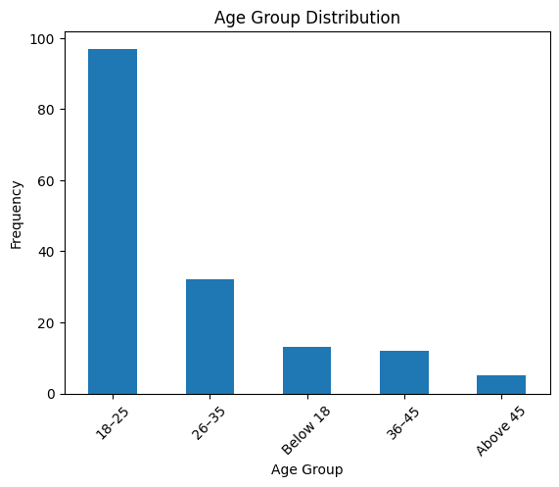

Digital Payment Method Usage
Respondents reported using multiple digital payment methods such as UPI, debit cards, credit cards, mobile wallets, and net banking. Among these methods, UPI-based payments emerged as the most commonly used and preferred method, indicating the growing popularity of instant payment systems.
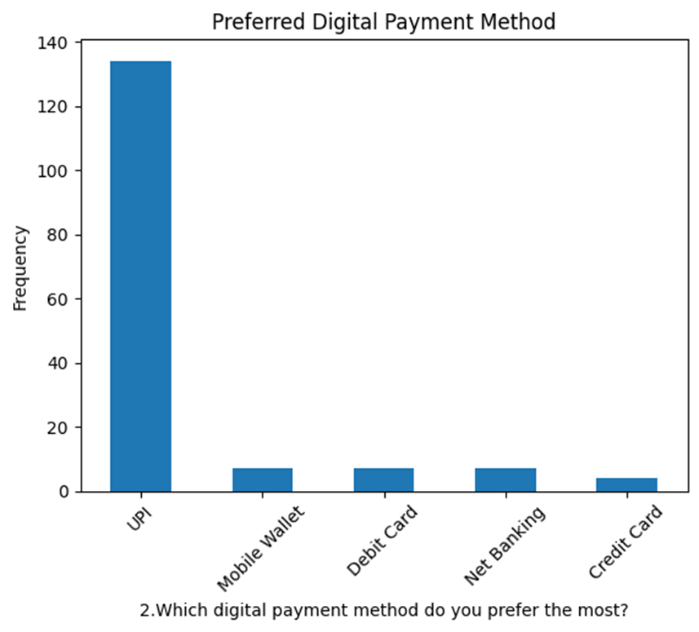

Preferred Digital Payment Application
The analysis of preferred applications showed that users tend to favor widely used applications such as Google Pay, PhonePe, and Paytm. These platforms are preferred due to their ease of use, accessibility, and availability of additional features.
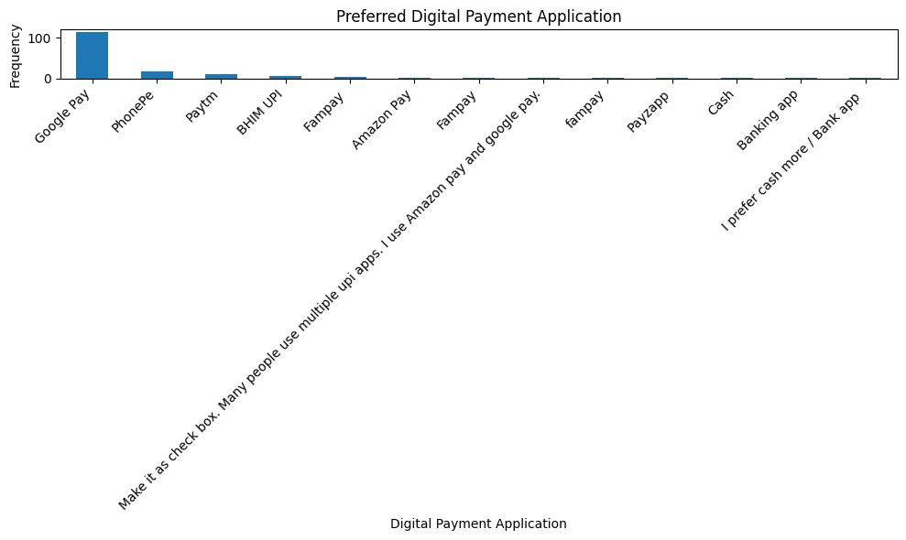

Usage Frequency
The frequency analysis revealed that a majority of respondents use digital payments daily or frequently, which highlights the increasing dependence on digital transactions for everyday financial activities.

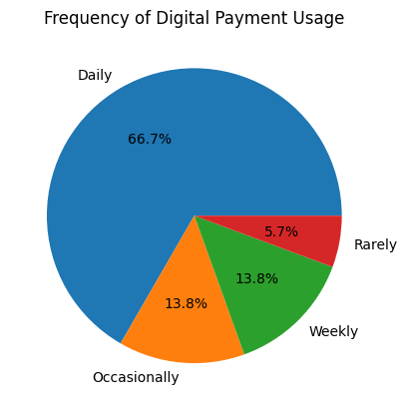
2.Reliability Analysis (Cronbach’s Alpha)

What it is
Cronbach’s Alpha is a statistical measure used to evaluate the internal consistency of a questionnaire, especially when multiple Likert-scale items measure the same concept.
Why it is used
In this study, Cronbach’s Alpha was used to determine whether the questionnaire items measuring:
- Convenience
- Ease of use
- Security
- Cashback rewards
are reliable and consistent.
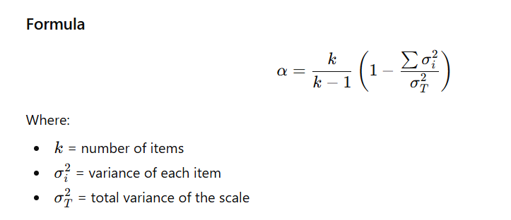

Alpha Value | Reliability
> 0.9 | Excellent
0.8 – 0.9 | Good
0.7 – 0.8 | Acceptable
0.6 – 0.7 | Moderate

To measure the internal consistency of the Likert-scale variables related to factors influencing digital payment preferences (such as convenience, ease of use, security, and cashback offers), Cronbach’s Alpha was calculated.
Cronbach’s Alpha helps determine whether the questionnaire items measuring similar concepts are consistent and reliable.
The reliability analysis produced an Alpha value of approximately 0.739.
Since the obtained value (0.739) lies between 0.7 and 0.8, it indicates acceptable internal consistency among the variables used in the questionnaire.
This suggests that the items measuring factors influencing digital payment preferences are reliable and suitable for further statistical analysis.

3. Test for Association between Age Group and Preferred Digital Payment Method
What it is:
- Chi-Square Test of Independence: A non-parametric statistical test to determine if there is a significant association between two categorical variables. However, it requires a sufficient number of observations in each category (expected frequencies).
- Fisher's Exact Test: A non-parametric statistical test that is an exact test of the significance of the association between two categorical variables, particularly useful when sample sizes are small or when the expected frequencies in a contingency table are low, violating the assumptions of the Chi-Square test.
Why it was used:
In this study, an initial Chi-Square Test was conducted to examine the relationship between 'Age Group' and 'Preferred Digital Payment Method'. However, the assumption regarding expected cell frequencies was significantly violated (84% of cells had expected frequencies less than 5). Therefore, Fisher's Exact Test was employed as a more robust and appropriate method to assess the association between these two categorical variables.
Hypothesis:
- Null Hypothesis (H₀): There is no association between age group and preferred digital payment method.
- Alternative Hypothesis (H₁): There is an association between age group and preferred digital payment method.

Decision Rule:
- If p < 0.05, then the null hypothesis is rejected.

Test Results:
- Fisher's Exact Test p-value: 0.0092

Interpretation:
Since the p-value from Fisher's Exact Test (0.0092) is less than 0.05, the null hypothesis is rejected. This indicates that there is a statistically significant association between age group and preferred digital payment method.

5. Strength of Association (Cramer’s V - Contextualized)
What it is:
Cramer’s V is a statistical measure used to determine the strength of association between two categorical variables, typically after performing a Chi-Square test. It ranges from 0 (no association) to 1 (perfect association).

Why it is used :
While Chi-Square shows whether a relationship exists, Cramer’s V indicates how strong the relationship is. However, since the Chi-Square test assumptions were violated, the Cramer's V value derived directly from it (0.282) should be interpreted with caution. Fisher's Exact Test does not directly provide a Cramer's V equivalent.

Test Results :
Cramer's V: 0.282

Interpretation:
If we were to consider the Cramer's V (0.282) from the initial Chi-Square calculation, it would suggest a moderate association between the variables. This would imply that different age groups tend to show different preferences for digital payment methods, and this relationship is of moderate strength. While Fisher's Exact Test confirms the existence of an association, a precise measure of its strength analogous to Cramer's V is not directly available from Fisher's test itself for larger tables, and the reported Cramer's V is from a test whose assumptions were violated.

Overall Conclusion: Despite the Chi-Square test's assumption violations, the more robust Fisher's Exact Test confirms a significant association between age group and preferred digital payment method. This suggests that age is a factor influencing the choice of digital payment methods among consumers.

5. Correlation Analysis
A correlation heatmap was generated to examine the relationships among various factors influencing digital payment preferences. These factors included:
- Convenience
- Ease of use
- Security
- Cashback and rewards
The correlation results indicated that these factors are positively related to each other, suggesting that users who value one factor (such as convenience) also tend to value other factors like ease of use and security.
Among these factors, convenience and ease of use showed relatively stronger correlations, indicating that these attributes play an important role in influencing digital payment adoption.
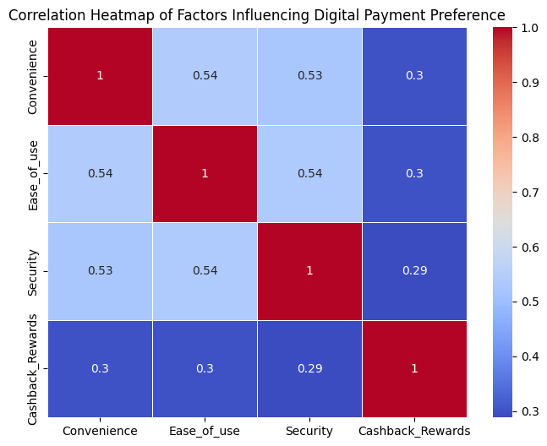

5.Most Important Factor
To understand the primary factor influencing users when selecting a digital payment method or application, respondents were asked to identify the most important factor affecting their choice. The responses were analyzed using a frequency distribution and visualized through a bar graph. The graph illustrates the number of respondents who selected each factor such as convenience, security, ease of use, and cashback or rewards. This analysis helps identify which factor plays the most significant role in influencing consumer preferences toward digital payment methods and applications.

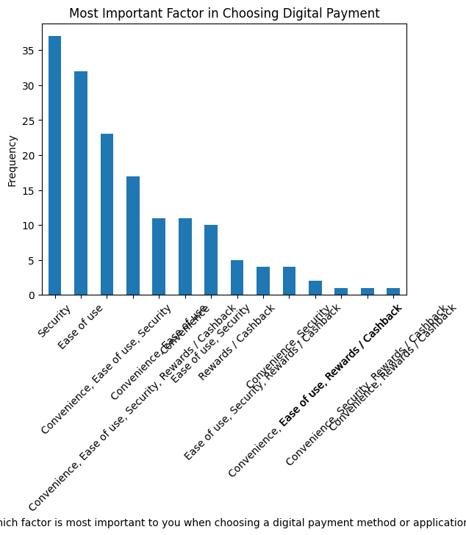

6.Qualitative Analysis (Open-Ended Responses)
In addition to quantitative questions, respondents were asked to provide open-ended feedback regarding their experiences with digital payment methods and applications.
The responses were analyzed and grouped into common themes. The most frequently mentioned themes included:
- Convenience and speed of transactions
- Security concerns and trust in payment platforms
- Preference for applications that provide cashback and reward offers
Some respondents also suggested improvements such as better transaction security, fewer technical errors, and improved user interfaces in digital payment applications.
This qualitative feedback complements the quantitative findings and provides deeper insights into user preferences and experiences.
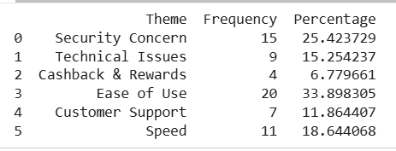

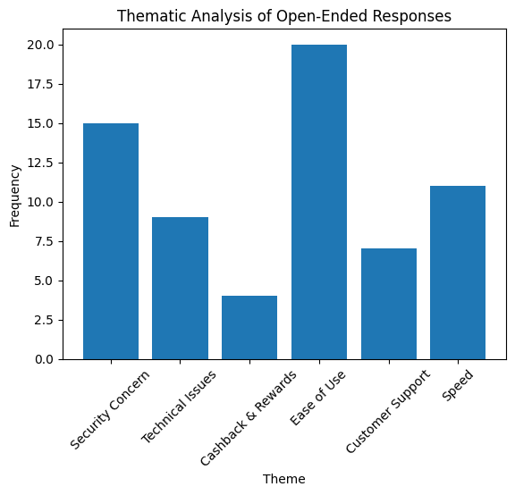

CONCLUSION
The study aimed to analyze consumer preferences for digital payment methods and applications and to identify the key factors influencing their usage. With the increasing adoption of digital technology and mobile applications, digital payments have become an important part of everyday financial transactions.
Based on the analysis of responses collected from 159 participants, it was observed that digital payment systems are widely used, particularly among younger age groups. The findings consistently indicate that users prioritize digital payment methods that offer convenience, ease of use, and secure transactions. Among the various digital payment options available, UPI-based payment systems and mobile payment applications were found to be the most commonly used and preferred by respondents.
Reliability analysis confirmed that the questionnaire used in the study was consistent, with a Cronbach’s Alpha value of 0.739, indicating acceptable internal consistency among the variables measuring influencing factors. To assess the association between age group and preferred digital payment method, an initial Chi-Square test was performed. However, due to significant violations of its assumptions (84% of cells having expected frequencies less than 5), a Fisher's Exact Test was conducted. This more robust test revealed a statistically significant association between age group and preferred digital payment method (p-value = 0.0092), suggesting that demographic characteristics indeed influence user preferences. The Cramer's V value of 0.282 from the initial Chi-Square (interpreted with caution due to assumption violations) suggests a moderate strength of this association.
Additionally, the correlation analysis showed positive relationships among factors such as convenience, ease of use, security, and cashback rewards, indicating that these factors collectively influence the adoption of digital payment systems. The qualitative analysis of open-ended responses further reinforced these findings, highlighting common themes around security, technical issues, ease of use, and the role of cashback/rewards.
Overall, the results strongly suggest that consumers are more likely to adopt digital payment applications that provide a secure, simple, and convenient transaction experience. While promotional incentives such as cashback offers can encourage usage, functional aspects like security and usability remain the most important determinants of user preference. These findings provide meaningful insights for digital payment service providers to improve their platforms by focusing on enhancing security features, simplifying user interfaces, and providing reliable services, thereby encouraging wider and more confident adoption of digital payment technologies.

LIMITATIONS
This study provides valuable insights into consumer preferences for digital payment methods; however, it is important to acknowledge certain limitations that may influence the generalizability and interpretation of the findings:
- Sample Size and Representativeness: The analysis was based on responses from 159 participants. While this provided sufficient data for the statistical tests conducted, it may not be fully representative of the entire consumer population, particularly across diverse geographical regions or socio-economic backgrounds. The method of participant recruitment was not specified, potentially introducing selection bias.
- Self-Reported Data: The data was collected through a survey, relying on participants' self-reported preferences and perceptions. This approach is susceptible to biases such as social desirability bias, where respondents may provide answers they believe are socially acceptable, or recall bias, where participants may not accurately remember their usage patterns or motivations.
- Ordinal Nature of Likert Scale Data: While Likert scale data (e.g., for convenience, ease of use, security, cashback/rewards) was treated as interval data for calculating means and Pearson correlations, it is inherently ordinal. Although common in social sciences, treating ordinal data as interval can affect the precision of some statistical interpretations. To address this, Spearman's Rank Correlation was also considered, which is more appropriate for ordinal data.
- Chi-Square Test Assumption Violations: The initial Chi-Square Test for the association between age group and preferred digital payment method showed significant violations of its assumptions, with 84% of cells having expected frequencies less than 5. While Fisher's Exact Test was subsequently used to confirm the statistical significance of the association, the interpretation of the strength of association (e.g., Cramer's V) from the Chi-Square test should be approached with caution.
- Scope of Influencing Factors: The study focused on specific factors influencing digital payment preference (convenience, ease of use, security, and cashback/rewards). There may be other unexamined factors (e.g., cultural norms, government policies, technological infrastructure, trust in specific brands) that also play a significant role in shaping consumer choices.
- Qualitative Data Depth: While qualitative insights from open-ended comments provided valuable context, the depth and volume of these comments might not be extensive enough to capture the full spectrum of user experiences and suggestions comprehensively.

FUTURE SCOPE
The present study provides valuable insights into consumer preferences for digital payment methods and applications. To further deepen the understanding of digital payment adoption and usage, several promising avenues for future research are identified:
- Expanded Sample and Generalizability: Future studies should aim for a larger and more diverse sample size, including respondents from different geographical regions, socio-economic strata, occupations, and age groups. This will enhance the representativeness of the findings and improve their generalizability across various consumer segments.
- Exploration of Additional Influencing Factors: Beyond the factors examined in this study, future research could investigate other critical determinants of digital payment adoption. These may include technological awareness, the level of trust in digital platforms, internet connectivity infrastructure, perceived risk, security concerns, and financial literacy levels among users. Understanding these variables will provide a more comprehensive view of consumer decision-making.
- Comparative Analysis of Platforms: Conducting comparative studies between different digital payment platforms or applications could yield insights into specific features, user experiences, and marketing strategies that contribute most significantly to user satisfaction, loyalty, and market penetration.
- Application of Advanced Analytical Techniques: Utilizing more advanced statistical techniques and predictive models, such as regression analysis, structural equation modeling, or machine learning approaches, can help to uncover more complex relationships and better predict consumer behavior in digital payment usage.
- Longitudinal Studies: To capture the dynamic nature of digital payment ecosystems, longitudinal studies are recommended. These studies would observe how consumer preferences, behaviors, and the influence of various factors evolve over time, especially as technology and financial services continue to advance.
- Impact of Regulatory and Policy Environments: Investigating the role of regulatory frameworks, government policies, and industry standards in shaping both consumer adoption and provider innovation within the digital payment landscape could offer crucial insights for policymakers.
Overall, continued research in these areas will be instrumental in helping policymakers, financial institutions, and digital payment providers develop more efficient, secure, and user-friendly payment solutions, ultimately fostering wider and more inclusive adoption of digital financial services.

BIBLIOGRAPHY

Zehra, F., Khan, F. S., Mazhar, S. S., Akhlaque, N., Haque, E., & Singh, A. (2024). Exploring consumer preferences and behaviour toward digital payment gateways in India. International Journal of Experimental Research and Review, 41(Spl Vol), 158–167.
Hemamalini, E., & Nedumaran, G. (2024). An analysis of consumer preferences and usage patterns of digital payment apps. International Journal of Research and Analysis in Commerce and Management.
Huggi, M. M., Bhuwaneshwari, R., & Udagi, K. (2024). The impact of digital payment systems on consumer behaviour in India. ShodhKosh Journal.
Mehta, R. (2024). Impact of digital payment systems on consumer behavior: A study in emerging economies. International Insurance Law Review.

Questionnaire link:
https://docs.google.com/forms/d/e/1FAIpQLSeKPhQ35HsHl21uRgcyUe41MXshITlQHyQKq6ene8Ngaq6uGQ/viewform

